Java Programming: Practical 3

**Q1 – Type, Save and Run the following code:**

**import** java.util.Scanner;//Imports Code That Allows Values Typed At The Keyboard To Be Used In Java Programs

**public** **class** Q1 {

**public** **static** **void** main(String[] args) {

// **TODO** Auto-generated method stub

Scanner keyboardIn = **new** Scanner(System.***in***);

//Declare Variables

String firstName;

String surname;

//Get Input

System.***out***.println("What Is Your First Name?");

firstName = keyboardIn.nextLine();

System.***out***.println("What Is Your Surname?");

surname = keyboardIn.nextLine();

//Output

System.***out***.println("Hi " + firstName + " " + surname + ", How Are You?");

}

}

**Q2 – Write a program that allows the user to input their first name and their favourite number. The program will output the following:**

Hello **<name>**!

Your lucky number is **<luckyNo>**!

**Q3 – Write a Java program for the following output. Declare suitable Variables, allow the user to input the data.**

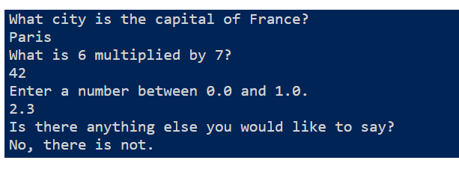

**Q4 –Write a Java program that asks the user for the following.**

1. **their first name (or their full name) (String),**
2. **the price per gallon of gasoline paid at the time of the last fill-up (double),**
3. **the total amount paid for the fill-up (double),**
4. **an initial odometer reading (int),**
5. **a final odometer reading (int)**

**Below is the sample screen**

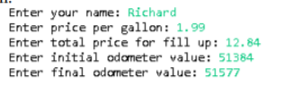

**Q5 - Write a Java program to print the following string in a specific format shown below. The program should use only one System.out.print method.**

